MODULE 6- DBMS110-12p- Oracle APEX screenshot:

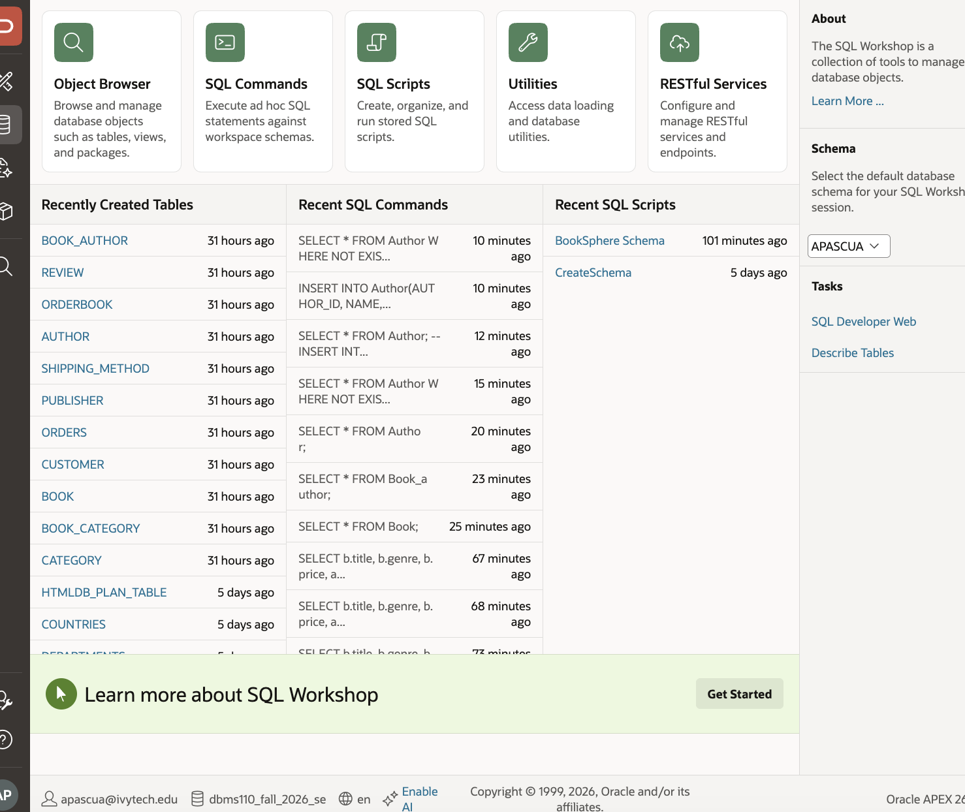

Module 6 -parts 4 – 5 queries- Arlyn M Pascua
M6 continue
- Insert Data: Write SQL statements to insert sample data into the tables.
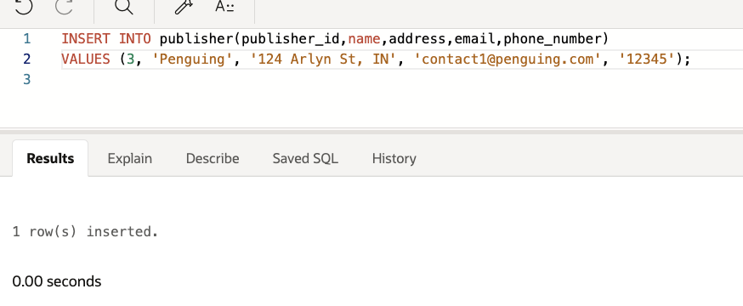
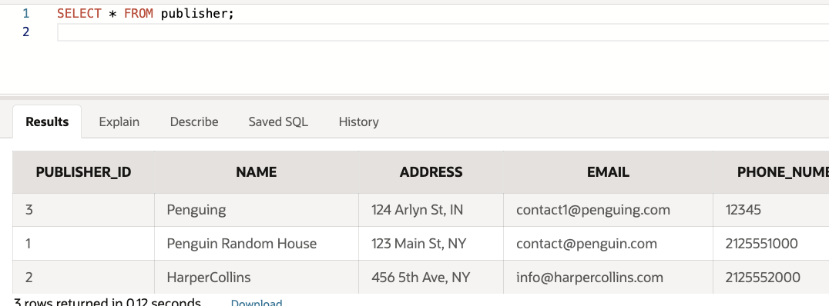
-------------------------------
- SQL Queries: Write SQL queries to perform the following tasks:
  - Retrieve all books written by a specific author.
  - Get the order history for a specific customer.
  - Find all reviews for a specific book.
  - Retrieve the list of books along with their category names.
  - Get all orders with their shipping method and tracking number.
  - Update the cost of a specific shipping method ID.
  - Delete records of authors who do not have any books being sold in the online bookstore. Ensure that only those authors with no associated books in the inventory are removed from the authors table.

- Retrieve all books written by a specific author.
/* 5a. Retrieve all books written by a specific author (George Orwell, author_id = 1) */
SELECT b.title, b.genre, b.price, a.author_id, a.name
FROM book b
JOIN book_author ba ON b.book_id = ba.book_id
JOIN author a ON ba.author_id = a.author_id
WHERE a.author_id = 1;
----------------------------------------------------------------------
- 5b: Get the order history for a specific customer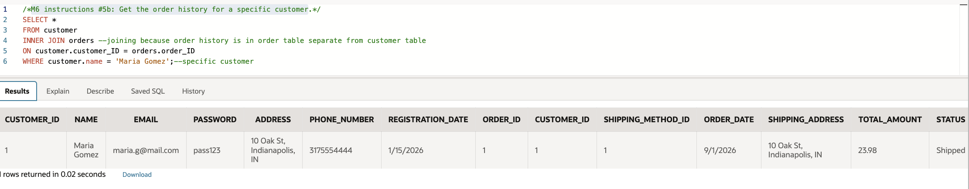
Part 5
5c: customer review book
- Find all reviews for a specific book
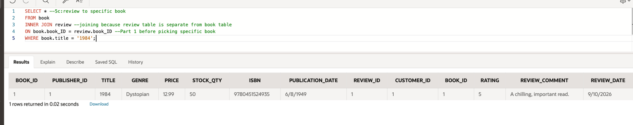
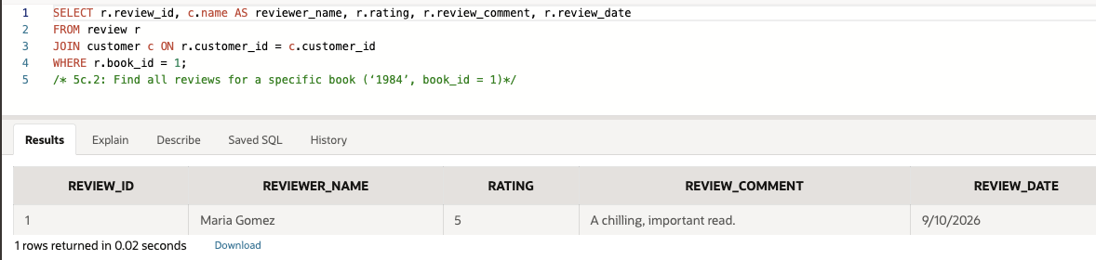
5c.3 version
SELECT review.review_id, customer.name AS reviewer_name, review.rating, review.review_comment, review.review_date
FROM Review review
JOIN customer customer ON review.customer_id = customer.customer_id
WHERE review.book_id = 1;
/* 5c.3: Find all reviews for a specific book (‘1984’, book_id = 1)*/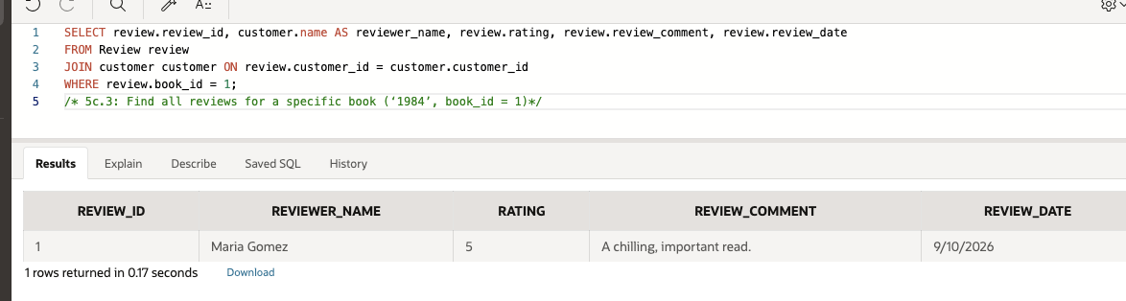
- 5d: Retrieve the list of books along with their category names.
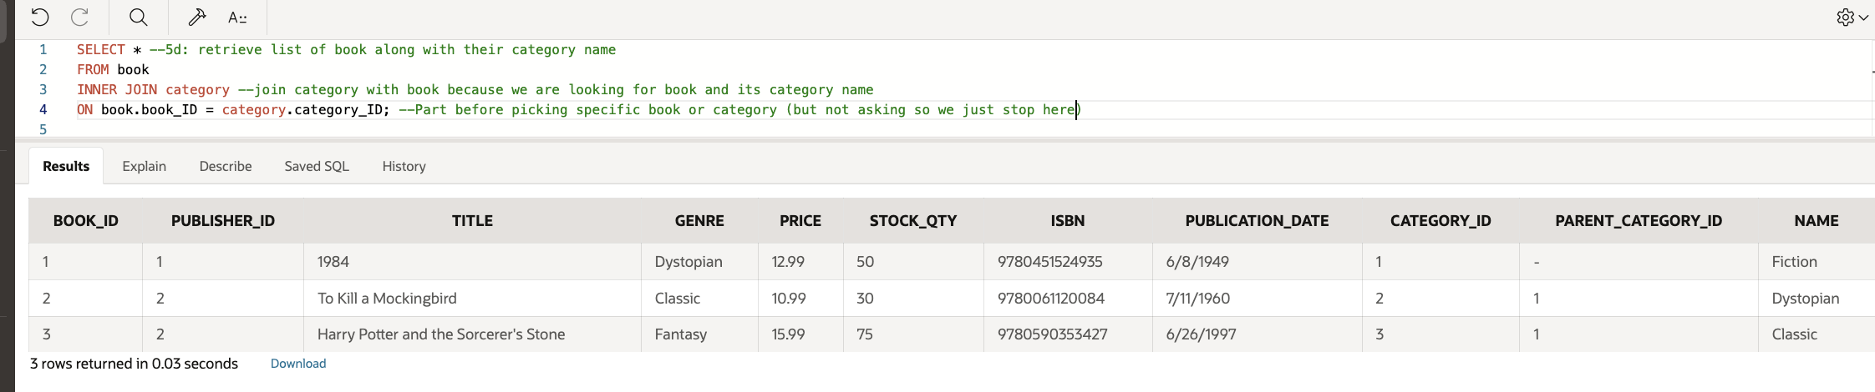

SELECT * --5e:Get all orders with their shipping method and tracking number
FROM orders;
Or
SELECT order_id, shipping_method_id, tracking_info
FROM orders; 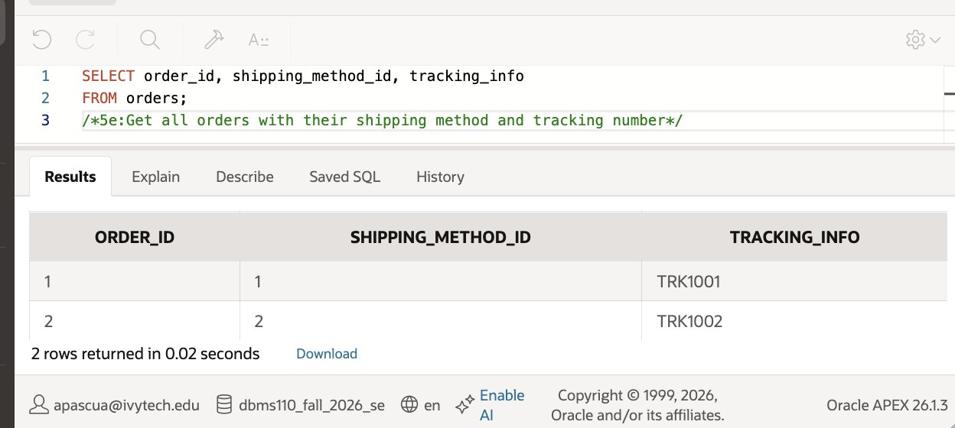
/*5e:Get all orders with their shipping method and tracking number*/
5f: Update the cost of a specific shipping method ID. 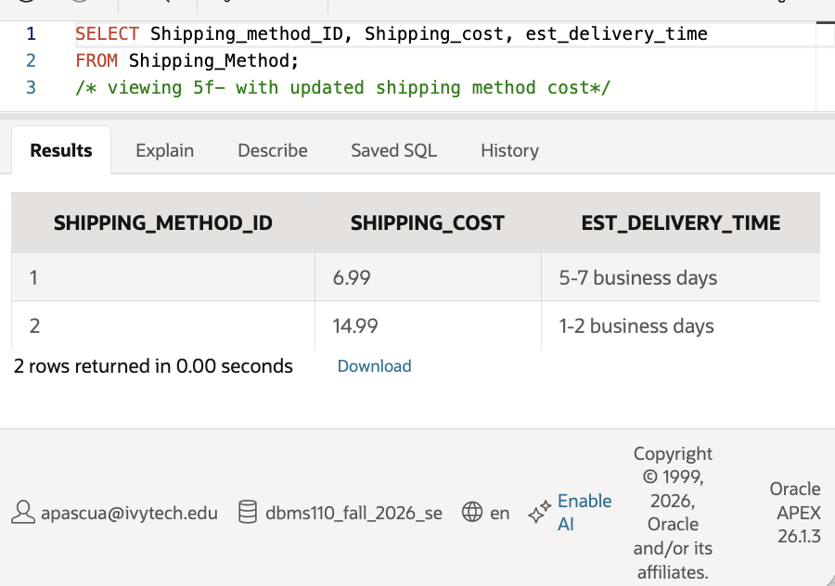/*before update*/
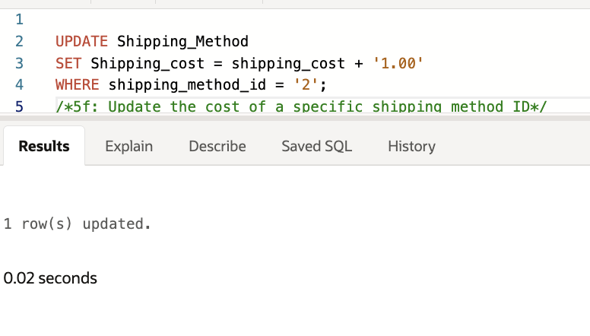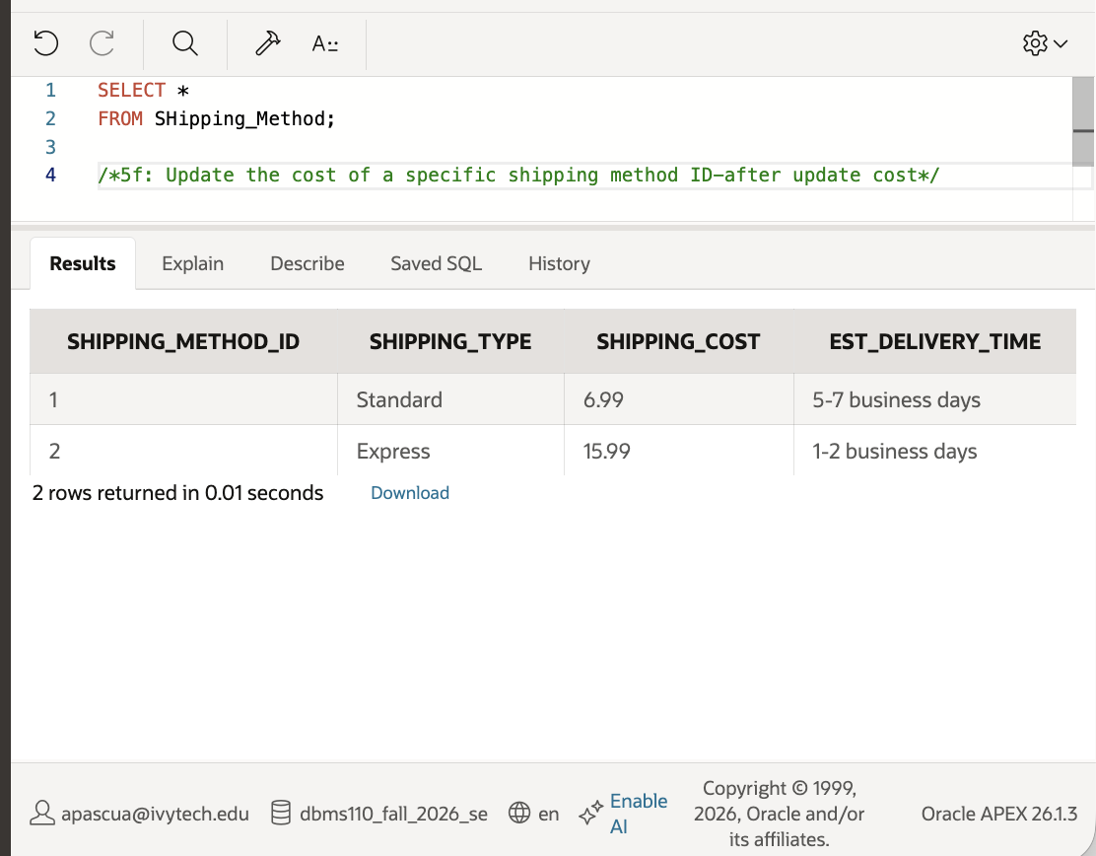/*after update*/
-----------------------------------

- G: Delete records of authors who do not have any books being sold in the online bookstore. Ensure that only those authors with no associated books in the inventory are removed from the authors table.
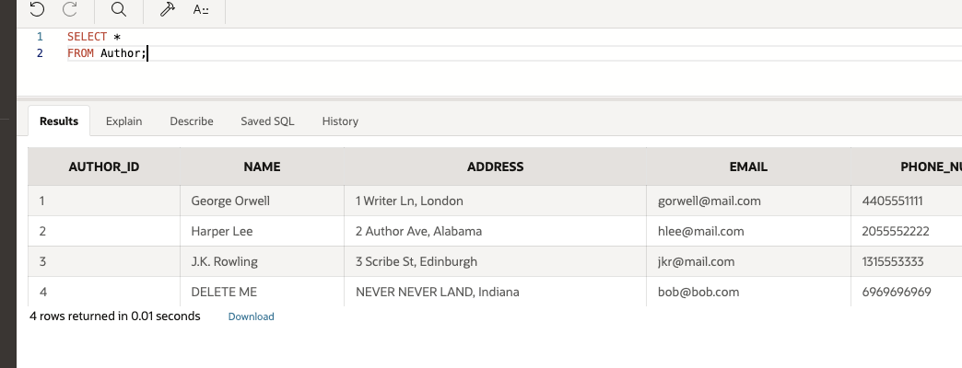
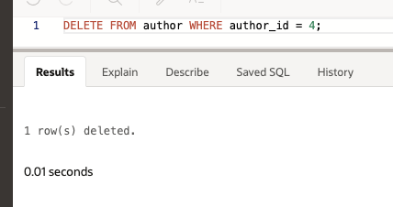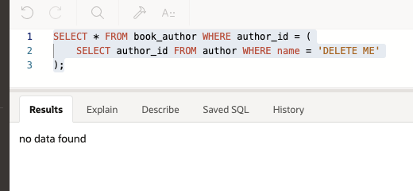
- 5g.v2: Delete records of authors who do not have any books being sold in the online bookstore. Ensure that only those authors with no associated books in the inventory are removed from the authors table.
